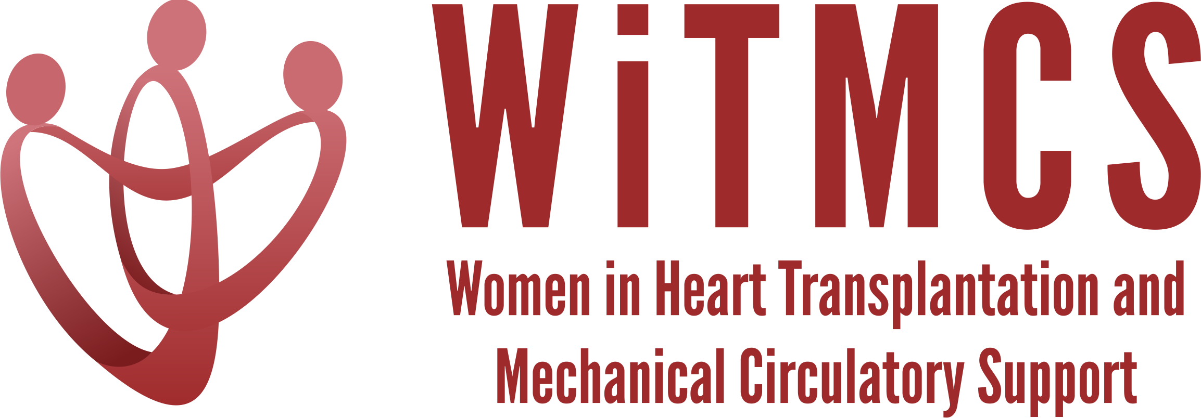

Research team: Agenda for 9/21/22 Zoom meeting (7-8 pm EST)

We will review updates and offer guidance on next steps for the newly proposed projects:

- Proposal for multi-center case series of protocols and outcomes for heart transplantation with COVID positive donors (expanding on the recent single-center case series from Duke, Geisinger)

- Updates on the new projects as below:
State of the Art Review type paper on induction therapy in HT | HCV NAT+ treatment systemic review, bringing together the various single center reports | “How To” paper on ambulating patients with temp MCS | State of the Art Review evaluation for HT of patients with pre-TX malignancy | Creatinine eGFR vs nuclear or cystatin C measures pre-LVAD | Multi-center case series of protocols and outcomes for heart transplantation with COVID positive donors
Johanna Contreras | Roopa Rao | Anju Bhardwaj | Dharini Ramu | Mirnela Byku | Nadia Fida,  Andriana Nikolova
Johanna updated: planning to have a second team meeting soon. A survey is planned as well. | Sonu and Roopa updated:  IBR submitted to Indiana University  Reviewed survey questionnaire, no changes made since IRB submitted  Question to limit to US or include Canada given insurance differences | Anju updated:  Working on data to form the basis of the project |  |  | Update from Nadia: We will make a first draft on data points and outcomes. We will set up a meeting with Shelley to go over registry process

- Updates on previously established projects:
  - Non-invasive imaging review: Response to reviewers submitted
  - SGLT2i cohort study (Joey and Priya), Priya updated: ready to share REDCaps and IRB materials with sites. Hopkins will not act as the central IRB. Each individual participating site must contact their own institutional IRB to make them aware of participation and if additional requirements must be met. For Institutions sending information to Hopkins the site PI must fill out an MTA request. Document detailing the needed steps with links attached. PDF of REDCaps and IRB attached.
  - Liver biopsy study (Anju and Yas), Anju updated: IRB has been submitted and approved by UT, Hermann pending. Looking for participating sites and Anju will send out an email soon.
- Priya has been selected for the HFSA podcast and is looking for topic suggestions

