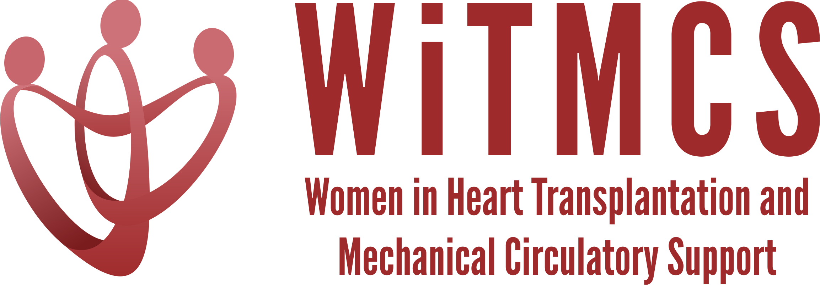

Research team: Minutes for 5/17/23 Zoom meeting (7-8 pm EST)
https://wellforce-hipaa.zoom.us/j/5788493823?from=addon

Present: Joey, Luise, Sharon, Sonu, Andriana, Nadia, Varinder, Amanda
Apologies: Priya, Teresa, Mirnela, Johanna

- SGLT2i cohort study (Joey and Priya): Instructions, a version of the protocol, the REDCaps data capture tool and the template DUA are all available here. Joey will add a tool to help navigate SlicerDicer. Note that there are dates that are entered, but the data that transmits to Hopkins for analysis will code out the identifying information. https://www.dropbox.com/scl/fo/5aoxp6w7vousfx9g0ruw2/h?dl=0&rlkey=ozil85igh4w84tsdf6yecpnva
Yale, Tufts, Baylor participating so far. Houston Methodist almost. Potential for Northwestern, Baptist Memorial Memphis.

- Liver biopsy study (Anju and Yas): Participating site PIs should follow the guidance in the “PI Instructions” Word doc – template DUA added:
https://www.dropbox.com/scl/fo/aw9696ipg8ligs35jm422/h?dl=0&rlkey=34ny8mu5nwbdw62n2qhy0sn23
Will request update from Anju as to participating centers.

- Preserving the kidney in HT recipients: from induction therapies to long term (Andriana, Mirnela, Varinder): Assigned sections, had one meeting, second meeting pending in 2 weeks. Nephrologist and PharmD also on the team.

- State of the Art Review type paper on induction therapy in HT (Andriana, Johanna): First draft completed, collected comments. Practical review paper. ?JACC:HF.

- HCV NAT treatment survey (Sonu and Roopa): Survey has been circulated, 11 responses thus far. Sending a second prompt through the WiTMCS website (Katherine to send).

- “How To” paper on ambulating with tMCS (Anju): Pending updates on timeline (pending publication of another paper).

- COVID-19 donors and subsequent recipient CAV risk (Andriana): Pending updates

- COVID-19 in HT recipients and subsequent rejection/CMV/CAV risk (Preethi): Connecting with Andriana

- Transplant recipients with a history of GCM (Luise): No current updates

- Survey of women VAD/TX leaders (Varinder): Re-approved by IRB with additional questions added, sending out before end of May (will need to be via email not website)

- Proposed cardiogenic shock Impella wean off VA-ECMO study, next step to apply for a grant for Abiomed (Copeland): Varinder updated that protocol docs are underway, group forming

- ERAS VAD/TX study proposal (Copeland): Reviewed concept, broad support

- Thursday evening co-writing group 5-6.30 pm ET: All are welcome!

