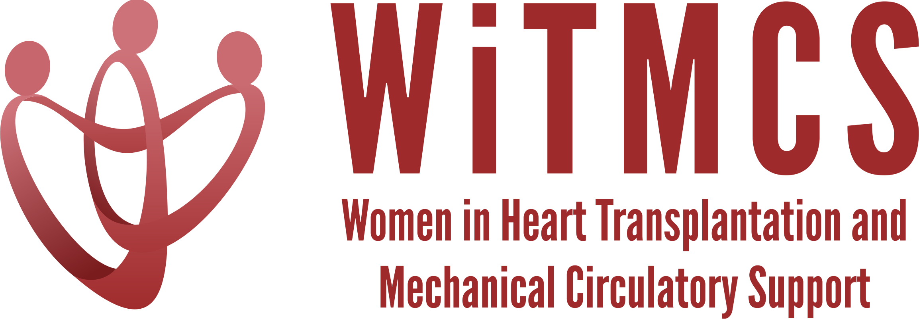

Research team: Minutes for 7/19/23 Zoom meeting (7-8 pm EST)
https://wellforce-hipaa.zoom.us/j/5788493823?from=addon

Present: Amanda, Nadia, Priya, Sharon, Theresa, Roopa, Johanna

- SGLT2i cohort study (Joey and Priya): Instructions, a version of the protocol, the REDCaps data capture tool and the template DUA are all available here. Joey will add a tool to help navigate SlicerDicer. Note that there are dates that are entered, but the data that transmits to Hopkins for analysis will code out the identifying info.
https://www.dropbox.com/scl/fo/5aoxp6w7vousfx9g0ruw2/h?dl=0&rlkey=ozil85igh4w84tsdf6yecpnva
Will review participating institutions: Already approved - Yale, Tufts, Duke, Penn, Baylor; Interested - Houston Methodist, Northwestern, Baptist Memorial Memphis, UCSF, Northwestern (Sonu Abraham once she starts 07/01). Queries at REDCaps: Clarify the ‘age’ timing for REDCaps entry (it is age at time of SGLT2i). Units for UACR.
Action: Update the Dropbox guidance doc to align with Priya’s recommended steps and check-in points.

- Liver biopsy study (Anju and Yas): Participating site PIs should follow the guidance in the “PI Instructions” Word doc, data collection form, DUA and protocol also inlcuded:
https://www.dropbox.com/scl/fo/aw9696ipg8ligs35jm422/h?dl=0&rlkey=34ny8mu5nwbdw62n2qhy0sn23
Action: Need to set up IRB and REDCaps at the central site.

- Preserving the kidney in HT recipients: from induction therapies to long term (Andriana, Mirnela, Varinder, Luise):
Assigned sections were being written and with a second meeting 06/26. Nephrologist and PharmD also on the team.

- State of the Art Review type paper on induction therapy in HT (Andriana, Johanna):
Second draft with edits currently being completed, pending meeting for review. Plan for submission as practical review paper to JACC:HF. Action: this Research group can perform review once drafting completed.

- HCV NAT treatment survey (Sonu and Roopa): Updates on survey participation will be given. Initial email was sent to the WiTMCS group and TX directors (12 responses total - -target 45). Action: Need to send a second prompt through the WiTMCS website.

- “How To” paper on ambulating with tMCS (Anju): Pending publication of another paper. Anju to begin practical review from September’s meeting.

- COVID-19 donors and subsequent recipient CAV risk (Andriana): Pending updates

- COVID-19 in HT recipients and subsequent rejection/CMV/CAV risk (Preethi): Pending updates

- Transplant recipients with a history of GCM (Luise): Pending updates

- Survey of women VAD/TX leaders (Varinder): Survey has been distributed. Plan for follow-up emails over the summer with the aim to analyze data in the fall.

- Proposed cardiogenic shock Impella wean off VA-ECMO study, next step to apply for a grant for Abiomed (Copeland): Group forming, meet in August to review next steps.

- ERAS VAD/TX study proposal (Copeland): Pending updates.

- Cardiac surgery research project (Larson): Sharon will contact other surgeons in the WITMCS group and collect ideas and then present options at our research group meeting (Hannah C, Amy H, Amy F, Marzia L etc)

- Thursday evening co-writing group 5-6.30 pm ET: All are welcome! https://wellforce-hipaa.zoom.us/j/5788493823?from=addon

