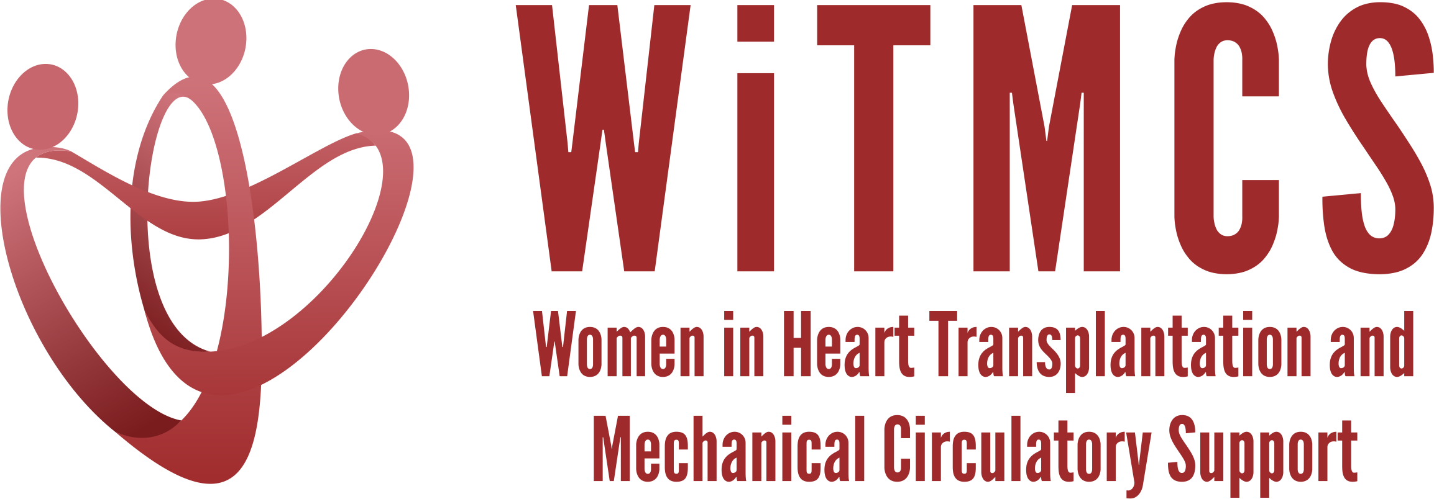

Research team: Agenda for 12/21/22 Zoom meeting (7-7.30 pm EST)

Present: Nosheen Reza, Shelley Hall, Luise Holzhauser, Evelyn Song, Amanda Vest

We reviewed updates as follows:

- Updates on previously established projects:

  - SGLT2i cohort study (Joey and Priya):

Participating site PIs should follow the guidance in the “Study Participation Guidelines” Word doc to complete the Materials Transfer Agreement (MTA) request. Please submit the MTA along with the Protocol and the REDCaps data capture tool all available here: https://www.dropbox.com/scl/fo/5aoxp6w7vousfx9g0ruw2/h?dl=0&rlkey=ozil85igh4w84tsdf6yecpnva

  - Liver biopsy study (Anju and Yas):

Participating site PIs should follow the guidance in the “PI Instructions” Word doc, which will be updated further as a MTA template becomes available.
https://www.dropbox.com/scl/fo/aw9696ipg8ligs35jm422/h?dl=0&rlkey=34ny8mu5nwbdw62n2qhy0sn23

- Updates on the newer projects as below:

State of the Art Review type paper on induction therapy in HT | HCV NAT+ treatment review  (survey based) | “How To” paper on ambulating patients with temp MCS | State of the Art Review evaluation for HT of patients with pre-TX malignancy | Creatinine eGFR vs nuclear or cystatin C measures pre-LVAD | Multi-center case series of protocols and outcomes for heart transplantation with COVID + donors | TX outcomes in pts with GCM | Survey of women leaders in VAD/TX centers
Johanna Contreras | Roopa Rao  Sonu Abraham | Anju Bhardwaj | Dharini Ramu | Mirnela Byku | Nadia Fida,  Andriana Nikolova | Luise Holzhauser | Varinder  Randhawa
Post-HT new ISHLT guidelines are out! Writing team will move forwards with an outline | Pending updates on whether the revised survey is IRB approved – will check in with leaders on next steps | Awaiting the collection of data about MCS practice and outcomes from lead site |  |  | We reviewed that there is still a space for this after the recently published Dec 2022 JHLT paper, esp given that our granularity of info about Rx is so much greater and can capture new info over time

