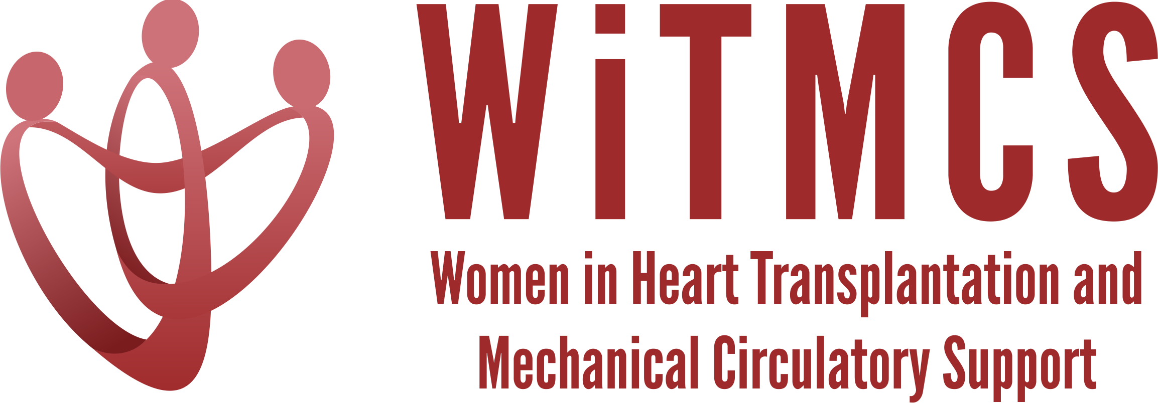

Research team: Minutes from 10/19/22 Zoom meeting (7-8 pm EST)

Present: Roopa Rao, Sonu Abraham, Priya Umapathi, Varinder Randhawa, Luise Holzhauser, Nadia Fida, Amanda Vest
Email updates from: Johanna Contreras, Dharini Ramu

- Updates on the new projects as below:
State of the Art Review type paper on induction therapy in HT | HCV NAT+ treatment review, which is now a clinical practice review (survey based) | “How To” paper on ambulating patients with temp MCS | State of the Art Review evaluation for HT of patients with pre-TX malignancy | Creatinine eGFR vs nuclear or cystatin C measures pre-LVAD | Multi-center case series of protocols and outcomes for heart transplantation with COVID positive donors | TX outcomes in pts with GCM | Survey of women leaders in VAD/TX centers
Johanna Contreras | Roopa Rao  Sonu Abraham | Anju Bhardwaj | Dharini Ramu | Mirnela Byku | Nadia Fida,  Andriana Nikolova | Luise Holzhauser | Varinder  Randhawa
From Johanna: Our group met and designed a survey regarding induction therapy to send to all the programs to get a sense of what every program is doing. With other papers and GLs coming out we did not want to be redundant and maybe better to use the survey to guide the paper. Possibility of a Qu-based paper format. | We reviewed the google forms for this project and suggested a couple edits for the team to submit as an amendment as to the IRB  We will need to liaise and cooperate with the CPR committee given the overlap  Varinder offered to share the US/Canada TX PD’s email list  Maybe the JACC:HF “How To” format | From Anju: awaiting data collection to form the backbone of this paper | From Dharini: pending a first meeting; Nadia and Sonu are ready and willing to participate! | No updates today | From Nadia: plans are evolving, pending a meeting | Pending a | Survey written, IRB approved and submitting an ammendment  Completing email distribution list (US and Canada, VAD and TX leaders)

We discussed the importance of mindfully sequencing the Induction, HCV and Program Leadership surveys to make sure the distribution list isn’t hit with separate emails in the same week. Luise suggested the possibility of combining the invitations to Induction (short) and HCV in the same email, which may work well. We also need to liaise with Mrdula and Imo from the CPR group.

- Updates on previously established projects:
  - Non-invasive surveillance review: A few minor reviewer responses, but accepted!

  - SGLT2i cohort study (Joey and Priya): shared REDCaps data collection form, IRB protocol and the JH link for the MTA request with interested participating centers last meeting. Each individual participating site must contact their own institutional IRB to make them aware of participation and if additional requirements must be met. For Institutions sending information to Hopkins the site PI must fill out an MTA request. A few centers are about to move forwards with their submissions.

  - Liver biopsy study (Anju and Yas): IRB approved, next step is for Anju to distribute IRB materials and MTA template to the interested participating centers.

