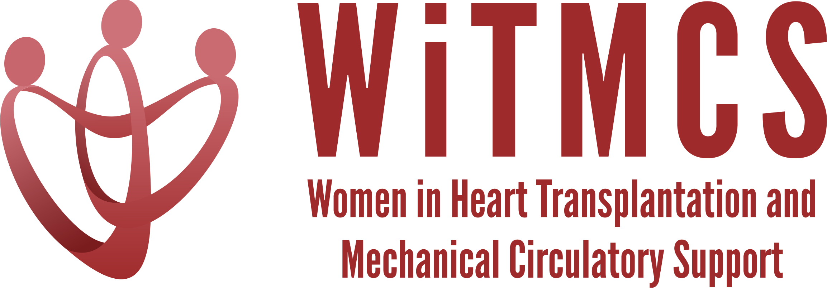

Research team: Agenda for 2/15/23 Zoom meeting (7-8 pm EST)
https://wellforce-hipaa.zoom.us/j/5788493823?from=addon

Present: Mirnela Byku, Amanda Vest, Patricia Chavez, Priya Umapathi, Johanna Contreras, Varinder Randhawa, Lavanya Bellumkonda, Melissa Lyle, Anju Bhardwaj, Sonu Abraham

- SGLT2i cohort study (Joey and Priya): There are some updates on the guidance for participating site PIs in the “Study Participation Guidelines” Word doc with regards to completing the Materials Transfer Agreement (MTA) request. Instructions, a version of the protocol, and the REDCaps data capture tool all available here: https://www.dropbox.com/scl/fo/5aoxp6w7vousfx9g0ruw2/h?dl=0&rlkey=ozil85igh4w84tsdf6yecpnva
Will add Tufts-JHU DUA as a template once ready.
In process thus far: Baylor, Tufts, Houston Methodist. Pending: Yale, Mt Sinai

- Liver biopsy study (Anju and Yas): DUA template added to the Dropbox:
https://www.dropbox.com/scl/fo/aw9696ipg8ligs35jm422/h?dl=0&rlkey=34ny8mu5nwbdw62n2qhy0sn23
Interested: Mt Sinai, Tufts, Houston Methodist, UNC

- Preserving the kidney in HT recipients: from induction therapies to long term (Andriana, Mirnela): new proposal. Would encompass a spectrum of literature from pre-HT (vs HK eval), IS choices, predictors of deterioration, renal biopsy etc. Call for additional volunteers. Mirnela will send out a brief outline and timeline in the next 2 weeks. Dr Kobashigawa advised Andriana it might be possible to arrange an expert consensus conference on the topic through AST.

- Survey of women with HF of reproductive age with VAD/TX regarding their knowledge of reproductive health (Patricia Chavez): new discussion, currently a single center study at Montefiore. Interested centers to connect with Patricia.

- State of the Art Review type paper on induction therapy in HT (Johanna): Team met, sections assigned. First review in 3 week. There is a document coming out in JHLT on this topic? Survey questions prepared for centers about current induction practices.

- HCV NAT treatment survey (Sonu and Roopa): Support received from the CPR committee. Survey submitted to Indiana U’s IRB. Have a list of US/Canadian medical/surgical directors ready to go. Discussed formatting the survey email with WiTMCS branding and a brief explanation/introduction to group.

- “How To” paper on ambulating with tMCS (Anju): Survey is underway (84 responses so far), hoping to present and publish. Then will base the How To around these results.

- Recipients of COVID-19 donors and CAV risk (Andriana): No updates today, planning stage ongoing.

- Transplant recipients with a history of GCM (Luise): Planning for multi-center retrospective report on post-HT outcomes, rejection, disease recurrence, and ?cfDNA in patients with GCM as their diagnosis. Proposal to include GCM that recovered (at least those that were evaluated/listed and not transplanted).

- Survey of women VAD/TX leaders (Varinder): Hannah and Varinder submitted IRB amendment with updated survey questions. Once approved, will send out. ?Submit for ATS/ATC.

- Upcoming Spring 2023 meetings or other presentation opportunities: The Research group is available for feedback and coaching on upcoming presentation talks

