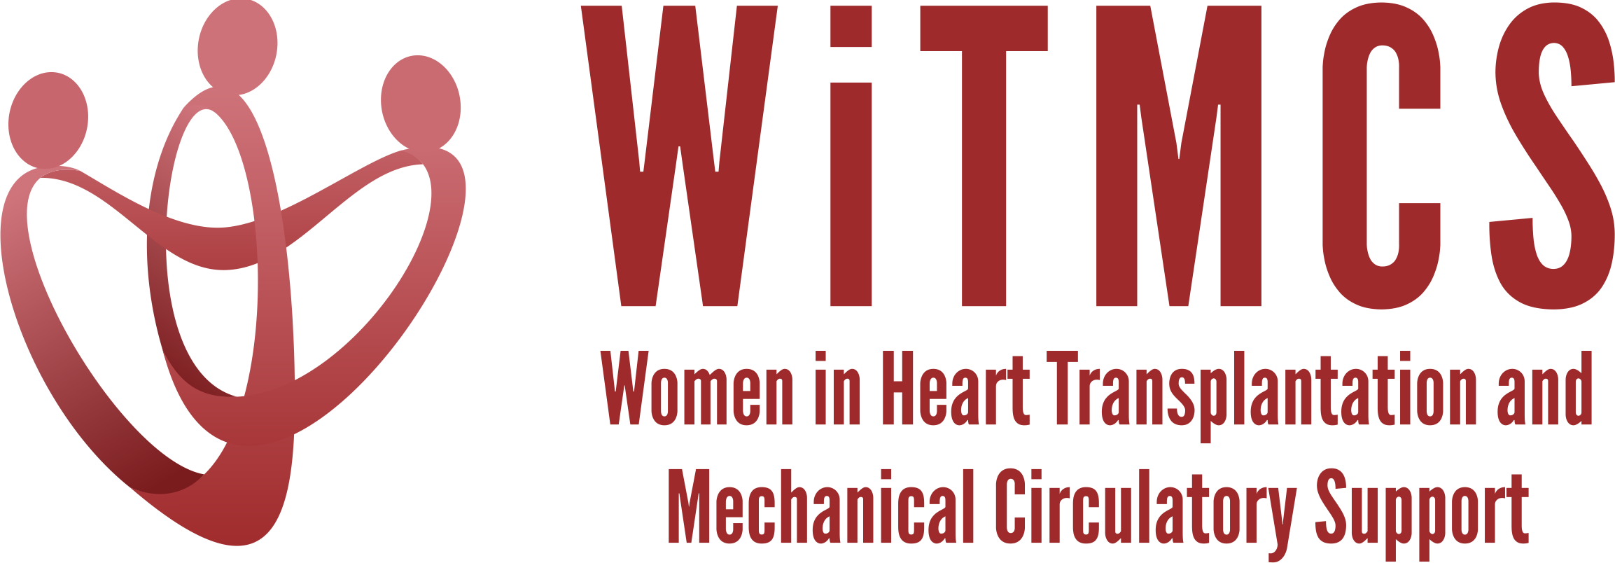

Research team: Minutes for 3/20/24 TEAMS meeting (7-8 pm EST)

Present: Priya, Amy, Amanda, Natalie, Minnow, Luise, Nadia, Johanna, Melissa, Teresa, Varinder

- Future of the WiTMCS Research Team! We anticipate an evolution in leadership for this group in Spring 2024. Formal announcement of new Chair pending.

- SGLT2i cohort study (Joey and Priya): Instructions, a version of the protocol, the REDCaps data capture tool and the template DUA are all available here:
https://www.dropbox.com/scl/fo/5aoxp6w7vousfx9g0ruw2/h?dl=0&rlkey=ozil85igh4w84tsdf6yecpnva

Updates: Centers with data complete: Tufts, Duke, Baylor, JHU, Houston Methodist, UCSF (pending 10 pts)
- Approx 80 subjects entered as of 3/20/24.
Next step: Data to lock this weekend. Data quality analysis underway.
Goal: Share data adjudication results in April meeting.

- Liver biopsy study (Anju, Yas, Maryjane, Nadia): Participating site PIs should follow the guidance in the “PI Instructions” Word doc, data collection form, DUA and protocol also included:
https://www.dropbox.com/scl/fo/aw9696ipg8ligs35jm422/h?dl=0&rlkey=34ny8mu5nwbdw62n2qhy0sn23

Updates: Protocol development ideas, e.g. validating the liver risk score from CUMC
Next steps: Maryjane to reignite group and next steps in terms of protocol, sample size, CRF variables
Goal: Select site to host RedCAP and coordinate data entry, Nadia will help coordinate

- Association of genetic variants with post-LVAD outcomes (Natalie, Kristin, Roopa)
Heard updates from Natalie on revised study design which focuses on what proportion of LVAD recipients underwent genetic testing, at what stage in their pre/post LVAD journey, the yield of positive results and perhaps an analysis for outcomes incl RHF and arrhythmias.
Next steps: Natalie enquire whether Stanford IRB would be central IRB for a multi-center retrospective cohort. Also interest from Kristin with Northwestern genetics, Luise with Penn cohort, Roopa with Indiana cohort (prior publication).

- Pre-advanced therapies renal function assessment and risk assessment (Mirnela):
Status: First draft completed, Mirnela reviewing
Next steps: Target journal TBD

- State of the Art Review on induction therapy in HT (Andriana, Johanna, Nadia):
Updates: Updating with JACC:HF reviewer comments, restructuring paper and adding a summary after each section
Status: Awaiting summary statements from each section writer
Next steps: AV to review once sections combined

- HCV NAT treatment survey (Sonu and Roopa): Initial and follow-up email was sent to the WiTMCS group and TX directors (36 responses total, of which 34 have HCV NAT+ protocol, representing about 300 patients nationwide).
Status: Second draft by Sonu and Roopa reviewed by AV/Johanna and others, pending SH review
Next steps: AV nudged team; Submit to ?JCF vs JAHA

- “How To” paper on ambulating with tMCS (Anju):
Primary data paper has been published. Johanna will nudge Anju re timeline to begin practical review paper with team coordination.

- COVID-19 donors and subsequent recipient CAV risk (Andriana): Looking for collaborators, esp from centers that do post-transplant IVUS assessments. Planning to start in the next few weeks.

- COVID-19 in HT recipients and subsequent rejection/CMV/CAV risk (Preethi): Pending updates

- Transplant recipients with a history of GCM (Luise): Pending updates

- Survey of women VAD/TX leaders (Varinder, Hannah):
Status: Survey has been distributed, data collected, analysis to roll out this Spring.
Next steps: Analyzing and will start writing soon.

- Proposed cardiogenic shock Impella wean off VA-ECMO study, next step to apply for a grant for Abiomed (Varinder, Hannah):
Parallel, open group, observational study of individuals supported on VA-ECMO who either receive an Impella device for weaning vs no device for weaning. Group formed, draft protocol circulating, Hannah has a follow-up meeting with Bobby from Abiomed. We discussed the challenge of the observational multi-center design and the difficulties of avoiding confounding by indication/contraindication; if Abiomed are willing to sponsor (and if upcoming ACS-MI Impella CP trial were to meet endpoint) then a small RCT using Impella 5.5. would scientifically be the best next step.

- ERAS VAD/TX study proposal (Hannah): Pending updates.

- Cardiac surgery research project (Sharon, Amy): Sharon was planning to connect with other surgeons in the WITMCS group and collect ideas and then present options at our research group meeting (Hannah C, Amy H, Amy F, Marzia L etc). Outcomes in female vs male surgeon cases (or female present at the advanced HF program) for LVAD/TX (Amy to enquire if STS/Intermacs would provide such gender data). Areas of innovation for educational dissemination is another option e.g. around Impella access with smaller vessels.

