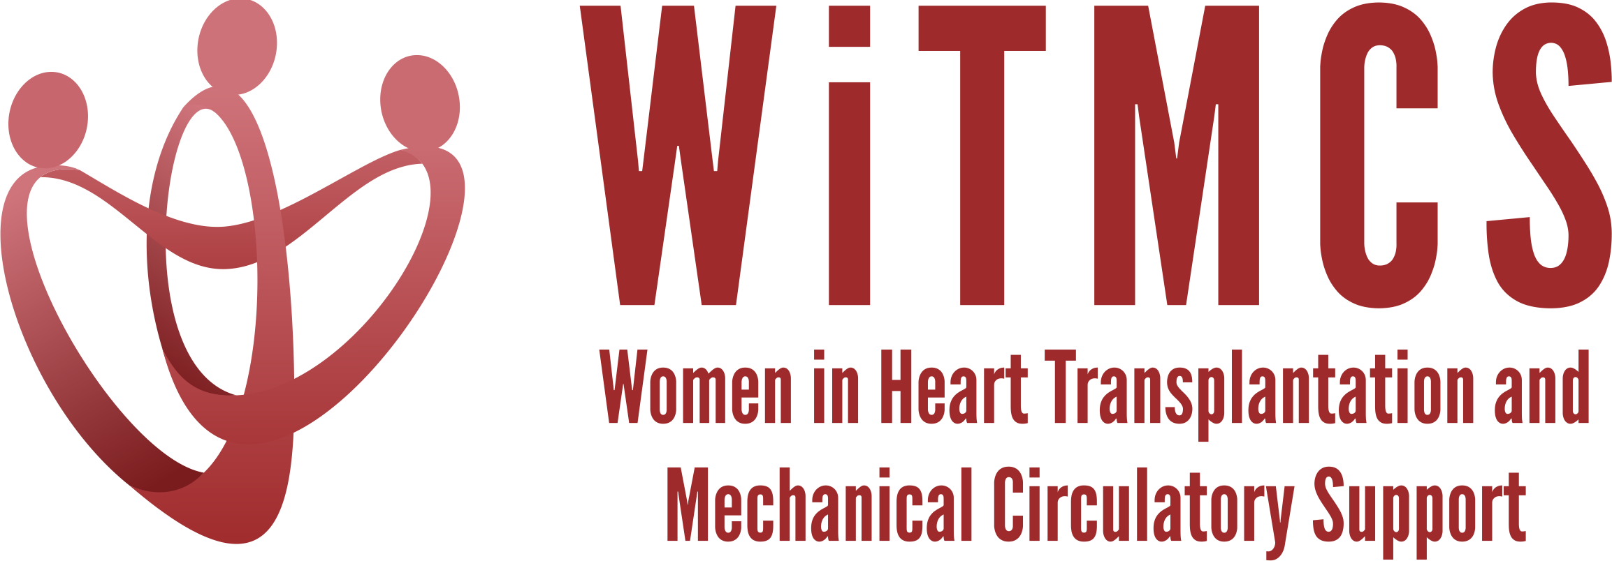

Research team: Minutes for 6/21/23 Zoom meeting (7-8 pm EST)
https://wellforce-hipaa.zoom.us/j/5788493823?from=addon

Present: Nadia Fida, Sharon Beth Larson, Luise Holzhauser

- SGLT2i cohort study (Joey and Priya): Instructions, a version of the protocol, the REDCaps data capture tool and the template DUA are all available here. Joey will add a tool to help navigate SlicerDicer. Note that there are dates that are entered, but the data that transmits to Hopkins for analysis will code out the identifying information.
https://www.dropbox.com/scl/fo/5aoxp6w7vousfx9g0ruw2/h?dl=0&rlkey=ozil85igh4w84tsdf6yecpnva
Will review participating institutions: Already approved - Yale, Tufts, Baylor; Interested - Houston Methodist, Northwestern, Baptist Memorial Memphis, UPenn, Northwestern (Sonu Abraham once she starts 07/01)

Question: Is the SlicerDicer/RedCap link ready for use. Is there a shared link? Nadia is ready to start data entry.

- Liver biopsy study (Anju and Yas): Participating site PIs should follow the guidance in the “PI Instructions” Word doc – template DUA added:
https://www.dropbox.com/scl/fo/aw9696ipg8ligs35jm422/h?dl=0&rlkey=34ny8mu5nwbdw62n2qhy0sn23
Will request update from Anju as to participating centers.

- Preserving the kidney in HT recipients: from induction therapies to long term (Andriana, Mirnela, Varinder, Luise):
Update: Assigned sections currently being written and plan for second meeting 06/26. Nephrologist and PharmD also on the team.

- State of the Art Review type paper on induction therapy in HT (Andriana, Johanna):
Update: Second draft with edits currently being completed, pending meeting for review. Plan for submission as practical review paper to JACC:HF.

- HCV NAT treatment survey (Sonu and Roopa): Updates on survey participation will be given. Has second prompt been sent through the WiTMCS website?
Update from Sonu Abraham: Received 12 responses in total. Dr. Clark will send survey out again to the 150 WITMCS members and the specific list of transplant directors.

- “How To” paper on ambulating with tMCS (Anju): Pending updates on timeline (pending publication of another paper).

- COVID-19 donors and subsequent recipient CAV risk (Andriana): Pending updates

- COVID-19 in HT recipients and subsequent rejection/CMV/CAV risk (Preethi): Pending updates

- Transplant recipients with a history of GCM (Luise): Pending updates

- Survey of women VAD/TX leaders (Varinder): Survey has been distributed, pending updates on responses
Update from Varinder: The leadership in advanced therapies survey was sent out on behalf of Hannah. Plan for follow-up emails over the summer with the aim to analyze data in the fall.

- Proposed cardiogenic shock Impella wean off VA-ECMO study, next step to apply for a grant for Abiomed (Copeland): Group forming, pending updates
Update from Varinder: Working on an Impella wean study grant with Hannah, intend to submit this study to Abiomed for funding

- ERAS VAD/TX study proposal (Copeland): Pending updates

- Thursday evening co-writing group 5-6.30 pm ET: All are welcome!

- Cardiac surgery research project: Sharon will contact other surgeons in the WITMCS group and collect ideas and then present options at our research group meeting.

