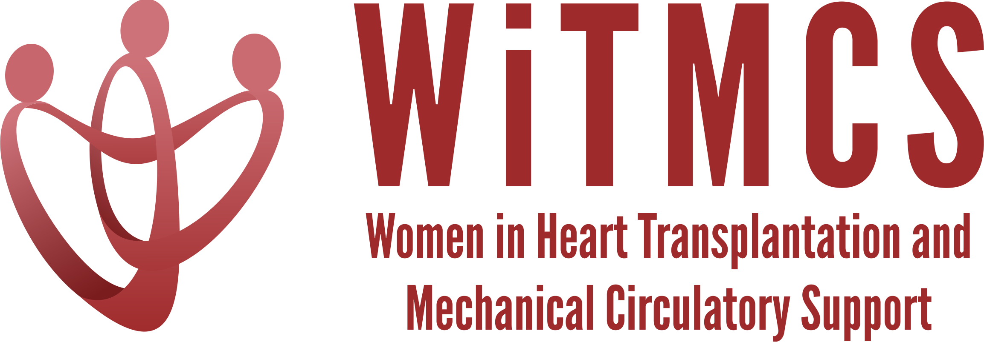

Research team: Minutes for 8/16/23 Zoom meeting (7-8 pm EST)
https://wellforce-hipaa.zoom.us/j/5788493823?from=addon

Present: Priya, Luise, Nadia, Farah, Amanda

- SGLT2i cohort study (Joey and Priya): Instructions, a version of the protocol, the REDCaps data capture tool and the template DUA are all available here:
https://www.dropbox.com/scl/fo/5aoxp6w7vousfx9g0ruw2/h?dl=0&rlkey=ozil85igh4w84tsdf6yecpnva

Updates: Already approved - Yale, Tufts, Duke, Baylor, JHU
Interested – Penn, Houston Methodist, Baptist Memorial Memphis, UCSF, Northwestern (Sonu Abraham once she starts 07/01)
Queries at REDCaps: Clarified the ‘age’ timing for REDCaps entry (it is age at time of data collection). Units for UACR.
Goal: Check in on October 15th on total sample size and data quality available from first wave of participants; more realistically looking for all data entered by end of 2023

- Liver biopsy study (Anju and Yas): Participating site PIs should follow the guidance in the “PI Instructions” Word doc, data collection form, DUA and protocol also included:
https://www.dropbox.com/scl/fo/aw9696ipg8ligs35jm422/h?dl=0&rlkey=34ny8mu5nwbdw62n2qhy0sn23

Updates: Tufts ready to submit to IRB, but needing central IRB approval
Goal: Need central IRB approval, review if this will still be UT Houston

- Preserving the kidney in HT recipients: from induction therapies to long term (Andriana, Mirnela, Varinder, Luise):
Nephrologist and PharmD also on the team. First drafts of sections have been submitted.

- State of the Art Review type paper on induction therapy in HT (Andriana, Johanna):
Updates: First revision of overall paper completed. Plan for submission as practical review paper to JACC:HF.
Action: This Research group can perform review once drafting completed.

- HCV NAT treatment survey (Sonu and Roopa): Initial email was sent to the WiTMCS group and TX directors (12 responses total - target 45). Goal: A second prompt through the WiTMCS website.

- “How To” paper on ambulating with tMCS (Anju): Pending publication of another paper. Anju to begin practical review from September’s meeting.

- COVID-19 donors and subsequent recipient CAV risk (Andriana): Pending updates

- COVID-19 in HT recipients and subsequent rejection/CMV/CAV risk (Preethi): Pending updates

- Transplant recipients with a history of GCM (Luise): Pending updates

- Survey of women VAD/TX leaders (Varinder): Survey has been distributed. Plan for follow-up emails over the summer with the aim to analyze data in the fall.

- Proposed cardiogenic shock Impella wean off VA-ECMO study, next step to apply for a grant for Abiomed (Copeland): Group forming, draft protocol circulating.

- ERAS VAD/TX study proposal (Copeland): Pending updates.

- Cardiac surgery research project (Larson): Sharon will contact other surgeons in the WITMCS group and collect ideas and then present options at our research group meeting (Hannah C, Amy H, Amy F, Marzia L etc)

- Thursday evening co-writing group 5-6.30 pm ET: All are welcome! https://wellforce-hipaa.zoom.us/j/5788493823?from=addon

- Other discussion: A very useful conversation on the pros, cons and strategies for pursuing industry-funded investigator initiated research. Prior experiences shared within the group.

