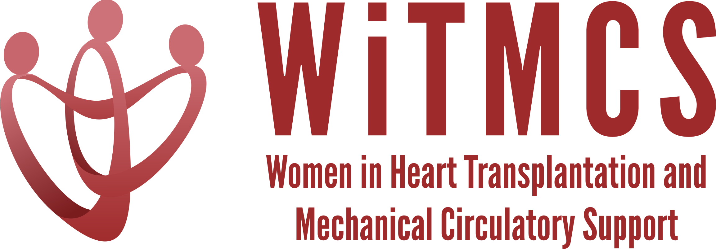

Academic Projects: Minutes from 8/16/22 Zoom meeting (7-8 pm EST)

We will review updates and offer guidance on next steps for the newly proposed projects:

- Proposal for multi-center case series of protocols and outcomes for heart transplantation with COVID positive donors (expanding on the recent single-center case series from Duke, Allegheny)

- Updates on the new projects as below:
State of the Art Review type paper on induction therapy in HT | HCV NAT+ treatment systemic review, bringing together the various single center reports | “How To” paper on ambulating patients with temp MCS | State of the Art Review evaluation for HT of patients with pre-TX malignancy | Creatinine eGFR vs nuclear or cystatin C measures pre-LVAD
Johanna Contreras | Roopa Rao | Anju Bhardwaj | Dharini Ramu | Mirnela Byku
Andriana updated: first team meeting completed, considering formats and a potential survey | Sonu updated: team decided to concentrate on timing, duration and type of therapy + survey for programs | Anju updated: data will focus on feasibility (complications) | Dharini email update: in the meeting phase

- Update on established projects:
  - Non-invasive imaging review: Response to reviewers underway
  - SGLT2i cohort study: EDC almost done, protocol for participating sites will come out soon
  - Liver biopsy study: IRB accepted, next steps EDC and protocol for participating sites

