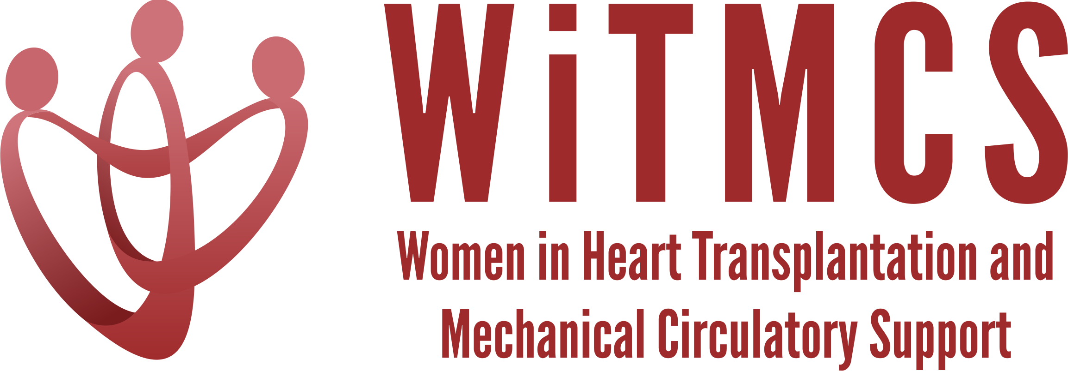

Research team: Minutes from 1/18/23 Zoom meeting (7-8 pm EST)

Present: Luise Holzhauser, Andriana Nikolova, Priya Umapathi, Evelyn Song, Nadia Fida, Roopa Rao, Sonu Abraham, Amanda Vest

We reviewed updates as follows:

- Updates on previously established projects:

  - SGLT2i cohort study (Joey and Priya):

There are some updates on the guidance for participating site PIs in the “Study Participation Guidelines” Word doc with regards to completing the Materials Transfer Agreement (MTA) request. Instructions, a version of the protocol, and the REDCaps data capture tool all available here: https://www.dropbox.com/scl/fo/5aoxp6w7vousfx9g0ruw2/h?dl=0&rlkey=ozil85igh4w84tsdf6yecpnva

  - Liver biopsy study (Anju and Yas):

Participating site PIs should follow the guidance in the “PI Instructions” Word doc, which will be updated further as a MTA template becomes available.
https://www.dropbox.com/scl/fo/aw9696ipg8ligs35jm422/h?dl=0&rlkey=34ny8mu5nwbdw62n2qhy0sn23

- Updates on the newer projects as below:

State of the Art Review type paper on induction therapy in HT | HCV NAT+ treatment review  (survey based) | “How To” paper on ambulating patients with temp MCS | State of the Art Review evaluation for HT of patients with pre-TX malignancy | Creatinine eGFR vs nuclear or cystatin C measures pre-LVAD | Multi-center case series of protocols and outcomes for heart transplantation with COVID + donors | TX outcomes in pts with GCM | Survey of women leaders in VAD/TX centers
Johanna Contreras | Roopa Rao  Sonu Abraham | Anju Bhardwaj | Dharini Ramu | Mirnela Byku | Nadia Fida,  Andriana Nikolova | Luise Holzhauser | Varinder  Randhawa
Post-HT new ISHLT guidelines are out! Writing team will move forwards with an outline  1/18: planning for next meeting now that ISHLT guidelines have been released | Pending updates on whether the revised survey is IRB approved – will check in with leaders on next steps  1/18: Plan to submit IRB today and survey has been completed. Working on paper outline.  Survey will be send out to US/Canada centers as soon as IRB approved.  Need to d/w CPR committee prior to sending final survey out. | Awaiting the collection of data about MCS practice and outcomes from lead site |  |  | We reviewed that there is still a space for this after the recently published Dec 2022 JHLT paper, esp given that our granularity of info about Rx is so much greater and can capture new info over time  1/18: Looking at funding options, best institutional based, possibly AST  Define research question, e.g. IVUS changes at 1 year in COVID positive donors  Granularity would add to data in contrast to data base analysis | 1/18: Follow up with CareDx on SHORE data request.

- Upcoming Spring 2023 meetings or other presentation opportunities: The Research group is available for feedback and coaching on upcoming presentation talks

