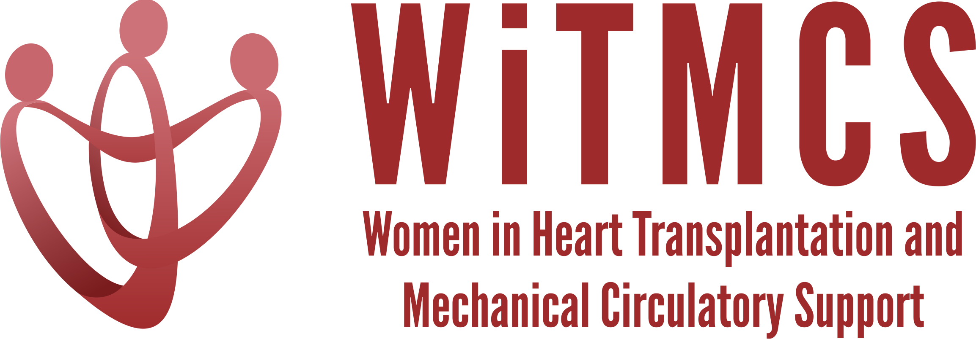

Research team: Minutes for 12/20/23 Zoom meeting (7-8 pm EST)
https://wellforce-hipaa.zoom.us/j/5788493823?from=addon

Present: Luise, Roopa, Nadia, Natalie, Priya, Amanda

- SGLT2i cohort study (Joey and Priya): Instructions, a version of the protocol, the REDCaps data capture tool and the template DUA are all available here:
https://www.dropbox.com/scl/fo/5aoxp6w7vousfx9g0ruw2/h?dl=0&rlkey=ozil85igh4w84tsdf6yecpnva

Updates: Centers with data complete: Tufts, Duke, Baylor, JHU, Houston Methodist, ?Yale, ?Sinai, ?UCSF
- 50 subjects entered as of 12/20/23
Next step: Data quality analysis can start now with Priya. Planning for data lock at end of December 2023.
Goal: Starting analyses in January. Statistician time to be allocated for Jan/Feb 2024.

- Liver biopsy study (Anju, Yas, Maryjane): Participating site PIs should follow the guidance in the “PI Instructions” Word doc, data collection form, DUA and protocol also included:
https://www.dropbox.com/scl/fo/aw9696ipg8ligs35jm422/h?dl=0&rlkey=34ny8mu5nwbdw62n2qhy0sn23

Status: Currently don’t have a central/coordinating IRB
Updates: Maryjane suggested excellent ideas for next steps, e.g. validating the liver risk score from CUMC
Next steps: Maryjane to reignite group and next steps in terms of protocol, sample size, CRF variables
Goal: Select site to host RedCAP and coordinate data entry

- Pre-operative risk factors for post-LVAD vasoplegia
Goal: Review project proposal, rationale for looking at novel predictors of vasoplegia including markers of HF severity, appropriate database sources.

- Association of genetic variants with post-LVAD outcomes
Goal: Review project proposal, rationale for evaluating genetics, potential data sources that are well genotyped.

- Pre-advanced therapies renal function assessment and risk assessment (Mirnela):
Status: First draft completed, Mirnela reviewing
Next steps: Target journal TBD

- Preserving the kidney in HT recipients: from induction therapies to long term (Andriana, Mirnela, Varinder, Luise):
Nephrologist and PharmD also on the team. First drafts of sections have been submitted.
Status: Liaising with AST, have a list of writers and an outcome
Next steps: Making writing assignments, first draft [clarify if this is the same paper as #5]

- State of the Art Review type paper on induction therapy in HT (Andriana, Johanna, Nadia):
Updates: Submitted in October for JACC:HF
Status: Pending reviewer comments

- HCV NAT treatment survey (Sonu and Roopa): Initial email was sent to the WiTMCS group and TX directors (17 responses total - target 20-25).
Status: A second prompt through the WiTMCS website, text for the message received!
Next steps: Email through WiTMCS new membership groups; personalized emails from Roopa. Plan to start analyzing responses in mid-January.

- “How To” paper on ambulating with tMCS (Anju): Pending publication of another paper. Anju to begin practical review from September’s meeting.

- COVID-19 donors and subsequent recipient CAV risk (Andriana): Looking for collaborators, esp from centers that do post-transplant IVUS assessments. Planning to start in the next few weeks.

- COVID-19 in HT recipients and subsequent rejection/CMV/CAV risk (Preethi): Pending updates

- Transplant recipients with a history of GCM (Luise): Pending updates

- Survey of women VAD/TX leaders (Varinder):
Status: Survey has been distributed, data collected.
Next steps: Download data from survey platform and begin analysis.

- Proposed cardiogenic shock Impella wean off VA-ECMO study, next step to apply for a grant for Abiomed (Copeland): Group forming, draft protocol circulating. Pending a follow-up meeting.

- ERAS VAD/TX study proposal (Copeland): Pending updates.

- Cardiac surgery research project (Larson): Pending updates. Sharon was planning to connect with other surgeons in the WITMCS group and collect ideas and then present options at our research group meeting (Hannah C, Amy H, Amy F, Marzia L etc)

- Thursday evening co-writing group 5-6.30 pm ET: All are welcome! https://wellforce-hipaa.zoom.us/j/5788493823?from=addon

