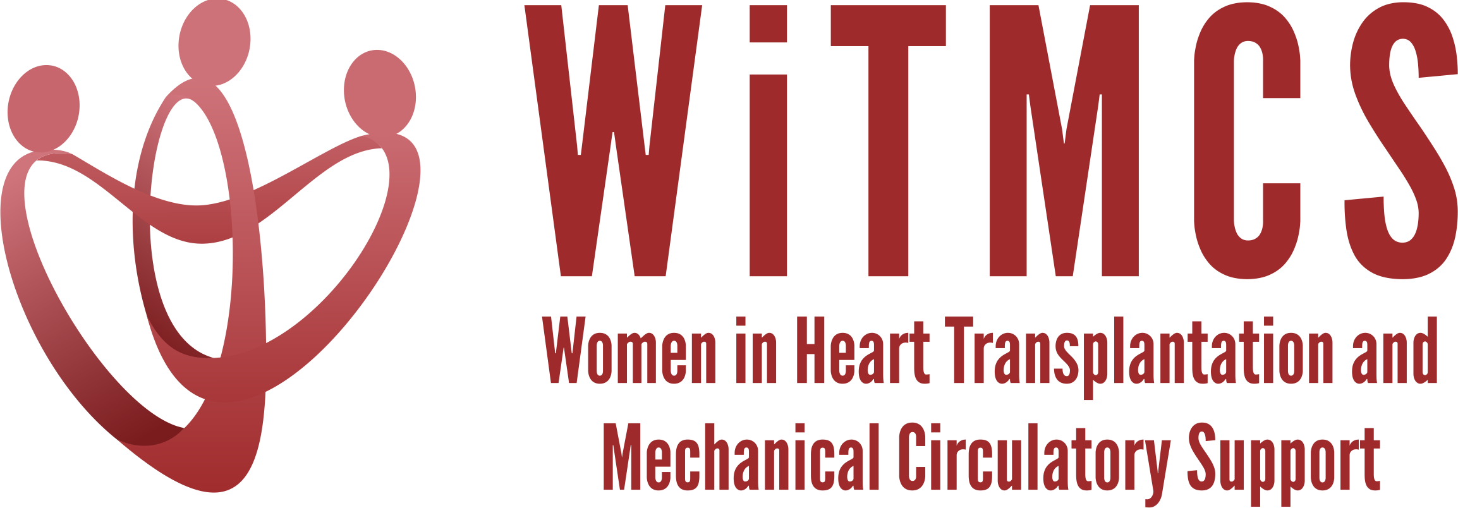

Research team: Minutes for 2/21/24 Zoom meeting (7-8 pm EST)
https://wellforce.zoom.us/j/99438250022?pwd=aE1zc1JTaWF4cTJUalBDd1FPaWYyUT09&from=addon

Present: Sharon Larson, Luise Holzhauser, Varinder Randhawa, Kristin Stawiarski, Adriana Nikolova, Roopa Rao, Nadia Fida, Johanna Contreras, Amanda Vest

- Future of the WiTMCS Research Team! From next month, there will be a Teams invitation from my Cleveland Clinic email. There will also be an evolution in leadership for this group in Spring 2024. Volunteers are still welcomed! Need to ensure a pipeline of trainees getting involved in this committee.

- SGLT2i cohort study (Joey and Priya): Instructions, a version of the protocol, the REDCaps data capture tool and the template DUA are all available here:
https://www.dropbox.com/scl/fo/5aoxp6w7vousfx9g0ruw2/h?dl=0&rlkey=ozil85igh4w84tsdf6yecpnva

Updates: Centers with data complete: Tufts, Duke, Baylor, JHU, Houston Methodist
- 50 subjects entered as of 12/20/23, what is the final count?
Next step: Is data locked as of end December 2023? Data quality analysis planning.
Goal: Statistician time to be allocated for Jan/Feb 2024.

- Liver biopsy study (Anju, Yas, Maryjane, Nadia): Participating site PIs should follow the guidance in the “PI Instructions” Word doc, data collection form, DUA and protocol also included:
https://www.dropbox.com/scl/fo/aw9696ipg8ligs35jm422/h?dl=0&rlkey=34ny8mu5nwbdw62n2qhy0sn23

Updates: Protocol development ideas, e.g. validating the liver risk score from CUMC
Next steps: Maryjane to reignite group and next steps in terms of protocol, sample size, CRF variables
Goal: Select site to host RedCAP and coordinate data entry, Nadia will help coordinate

- Pre-operative risk factors for post-LVAD vasoplegia (Natalie, Kristin)
Conversation: To achieve novelty, would need a very large and clean dataset aligned to the new ISHLT vasoplegia criteria; or would need a prospective biobanked cohort to investigate a few vascular markers or plegia components that could be mechanistic.
Goal: Reviewed project proposal, rationale for looking at novel predictors of vasoplegia including markers of HF severity, appropriate database sources.

- Association of genetic variants with post-LVAD outcomes (Natalie, Kristin, Roopa)
Goal: Reviewed project proposal, rationale for evaluating genetics, potential data sources that are well genotyped.
Next steps: Natalie to meet with a Stanford genetics colleague, Kristin with Northwestern genetics. Luise to enquire with Nosheen re Penn cohort. Roopa has an existing cohort and control group that could be further studied to evaluate longer term outcomes.

- Pre-advanced therapies renal function assessment and risk assessment (Mirnela):
Status: First draft completed, Mirnela reviewing
Next steps: Target journal TBD

Preserving the kidney in HT recipients: from induction therapies to long term (Andriana, Mirnela, Varinder, Luise):
- AST project, not being managed by the WiTMCS team

- State of the Art Review type paper on induction therapy in HT (Andriana, Johanna, Nadia):
Updates: Updating with JACC:HF reviewer comments, bringing together in March 1st
Status: AV to review once sections combined (~March)

- HCV NAT treatment survey (Sonu and Roopa): Initial and follow-up email was sent to the WiTMCS group and TX directors (28 responses total, of which 26 have HCV NAT+ protocol, representing about 250 patients nationwide).
Status: Second draft by Sonu and Roopa underway, pending AV re-review
Next steps: Submit to ?JCF vs JAHA

- “How To” paper on ambulating with tMCS (Anju): Pending publication of another paper. Anju to begin practical review drafting and team coordination.

- COVID-19 donors and subsequent recipient CAV risk (Andriana): Looking for collaborators, esp from centers that do post-transplant IVUS assessments. Planning to start in the next few weeks.

- COVID-19 in HT recipients and subsequent rejection/CMV/CAV risk (Preethi): Pending updates

- Transplant recipients with a history of GCM (Luise): Pending updates

- Survey of women VAD/TX leaders (Varinder, Hannah):
Status: Survey has been distributed, data collected, analysis underway.
Next steps: Analyzing and will start writing soon.

- Proposed cardiogenic shock Impella wean off VA-ECMO study, next step to apply for a grant for Abiomed (Varinder, Hannah): Group forming, draft protocol circulating. Pending a follow-up meeting with Bobby from Abiomed.

- ERAS VAD/TX study proposal (Hannah): Pending updates.

- Cardiac surgery research project (Sharon): Pending updates. Sharon was planning to connect with other surgeons in the WITMCS group and collect ideas and then present options at our research group meeting (Hannah C, Amy H, Amy F, Marzia L etc). Outcomes in female vs male surgeon cases for LVAD/TX. Areas of innovation for educational dissemination.

