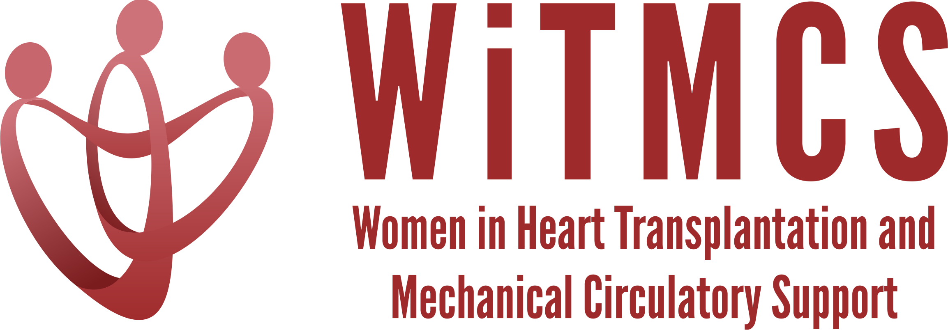

Research team: Agenda for 4/17/24 TEAMS meeting (7-8 pm EST)

Present: Priya, Amy H, Mahwash, Lakshmi, Sharon, Nadia, Amanda, Sonu, Johanna, Varinder

- Future of the WiTMCS Research Team! Amanda is handing over the leadership of this committee to Priya from next month, with Luise still serving as co-chair. Priya suggested a research newsletter or shared docs for providing updates on the projects.

- SGLT2i cohort study (Joey and Priya): Instructions, a version of the protocol, the REDCaps data capture tool and the template DUA are all available here:
https://www.dropbox.com/scl/fo/5aoxp6w7vousfx9g0ruw2/h?dl=0&rlkey=ozil85igh4w84tsdf6yecpnva

Updates: Centers with data complete: Tufts, Duke, Baylor, JHU, Houston Methodist, UCSF (pending 10 pts)
- 133 patients in REDCap final number (135 minus 2 Tufts subjects that were ineligible)
Next step: Data quality analysis underway, dataset to statistician Tuesday
Goal: Share initial results in May or June meeting

- Liver biopsy study (Nadia, Anju, Maryjane): Participating site PIs should follow the guidance in the “PI Instructions” Word doc, data collection form, DUA and protocol also included:
https://www.dropbox.com/scl/fo/aw9696ipg8ligs35jm422/h?dl=0&rlkey=34ny8mu5nwbdw62n2qhy0sn23

Updates: Protocol development ideas, e.g. validating the liver risk score from CUMC
Next steps: Nadia to connect with Maryjane to reignite group and next steps in terms of protocol, sample size, CRF variables
Goal: Select site to host RedCAP and coordinate data entry, Nadia will help coordinate

- Association of genetic variants with post-LVAD outcomes (Natalie, Kristin, Roopa, Mahwash)
Project will retrospectively review what proportion of LVAD recipients underwent genetic testing, at what stage in their pre/post LVAD journey, the yield of positive results and perhaps an analysis for outcomes incl RHF and arrhythmias.
Next steps: Natalie enquiring whether Stanford IRB would be central IRB for a multi-center retrospective cohort. Also interest from Kristin with Northwestern genetics, Luise with Penn cohort, Roopa with Indiana cohort (prior publication). Mahwash will connect Natalie re using central IRB and SMART form. Hopkins and Sinai can also contribute.

- Pre-advanced therapies renal function assessment and risk assessment (Mirnela):
Status: First draft completed, Mirnela reviewing
Next steps: Target journal TBD

- State of the Art Review on induction therapy in HT (Andriana, Johanna, Nadia):
Updates: Restructured paper and adding a summary after each section, reviewed and submitted
Status: Awaiting journal decision
Next steps:

- HCV NAT treatment survey (Sonu and Roopa): Initial and follow-up email was sent to the WiTMCS group and TX directors (36 responses total, of which 34 have HCV NAT+ protocol, representing about 300 patients nationwide).
Status: Submitted to JCF
Next steps: Pending review; JAHA or JACC Advances if not accepted

- “How To” paper on ambulating with tMCS (Anju):
Primary data paper has been published. Anju drafting practical review paper. Johanna, Amy Varinder, Lakshi still interested in participating in the writing.

- COVID-19 donors and subsequent recipient CAV risk (Andriana): Looking for collaborators, esp from centers that do post-transplant IVUS assessments. Planning to start in the next few weeks.

- COVID-19 in HT recipients and subsequent rejection/CMV/CAV risk (Preethi): Pending updates

- Transplant recipients with a history of GCM (Luise): Pending updates

- Survey of women VAD/TX leaders (Varinder, Hannah):
Status: Survey has been distributed, data collected, analysis to roll out this Spring.
Next steps: Analyzing and will start writing soon.

- Proposed cardiogenic shock Impella wean off VA-ECMO study, next step to apply for a grant for Abiomed (Varinder, Hannah):
Parallel, open group, observational study of individuals supported on VA-ECMO who either receive an Impella device for weaning vs no device for weaning. Group formed, draft protocol circulating, Hannah has a follow-up meeting with Bobby from Abiomed. We discussed the challenge of the observational multi-center design and the difficulties of avoiding confounding by indication/contraindication; if Abiomed are willing to sponsor (and if upcoming ACS-MI Impella CP trial were to meet endpoint) then a small RCT using Impella 5.5. would scientifically be the best next step.
Next steps: Discuss a possible RCT in light of DanGer-Shock results.

- ERAS VAD/TX study proposal (Hannah): Pending updates.

- Cardiac surgery research project (Sharon, Amy): Focus area is the relationship between sex, axillary artery size (and perceived size based on demographics), axillary tMCS complications.
Next steps: Sharon and Amy to discuss further and report back on a retrospective study plan.

- LVAD cannula positions (Mahwash): Single center protocol being established, which might be of interest to other centers for participation. Mahwash will share more info at the next meeting and provide a ‘blurb’.

