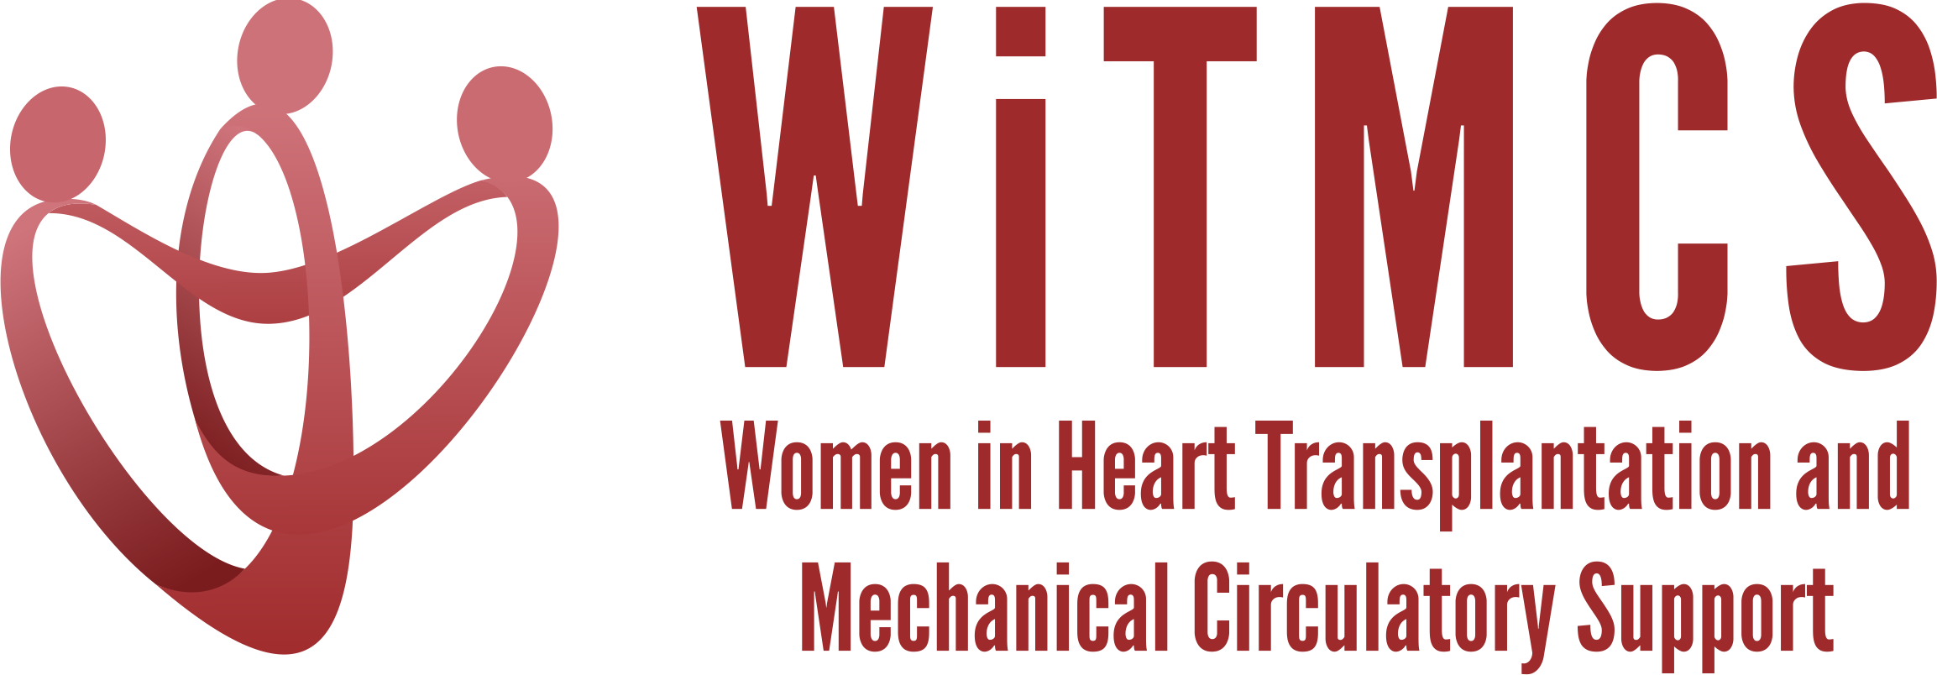

Research team: Minutes for 1/17/24 Zoom meeting (7-8 pm EST)
https://wellforce.zoom.us/j/99438250022?pwd=aE1zc1JTaWF4cTJUalBDd1FPaWYyUT09&from=addon

Present: Amanda, Nadia, Roopa

- SGLT2i cohort study (Joey and Priya): Instructions, a version of the protocol, the REDCaps data capture tool and the template DUA are all available here:
https://www.dropbox.com/scl/fo/5aoxp6w7vousfx9g0ruw2/h?dl=0&rlkey=ozil85igh4w84tsdf6yecpnva

Updates: Centers with data complete: Tufts, Duke, Baylor, JHU, Houston Methodist
- 50 subjects entered as of 12/20/23, what is the final count?
Next step: Is data locked as of end December 2023? Data quality analysis planning.
Goal: Statistician time to be allocated for Jan/Feb 2024.

- Liver biopsy study (Anju, Yas, Maryjane, Nadia): Participating site PIs should follow the guidance in the “PI Instructions” Word doc, data collection form, DUA and protocol also included:
https://www.dropbox.com/scl/fo/aw9696ipg8ligs35jm422/h?dl=0&rlkey=34ny8mu5nwbdw62n2qhy0sn23

Updates: Protocol development ideas, e.g. validating the liver risk score from CUMC
Next steps: Maryjane to reignite group and next steps in terms of protocol, sample size, CRF variables
Goal: Select site to host RedCAP and coordinate data entry, Nadia will help coordinate

- Pre-operative risk factors for post-LVAD vasoplegia (Natalie, Kristin)
Goal: Reviewed project proposal, rationale for looking at novel predictors of vasoplegia including markers of HF severity, appropriate database sources.

- Association of genetic variants with post-LVAD outcomes (Natalie, Kristin, Roopa)
Goal: Reviewed project proposal, rationale for evaluating genetics, potential data sources that are well genotyped.
Next steps: Natalie to meet with a Stanford genetics colleague. Roopa has an existing cohort and control group that could be further studied to evaluate longer term outcomes.

- Pre-advanced therapies renal function assessment and risk assessment (Mirnela):
Status: First draft completed, Mirnela reviewing
Next steps: Target journal TBD

- Preserving the kidney in HT recipients: from induction therapies to long term (Andriana, Mirnela, Varinder, Luise):
Nephrologist and PharmD also on the team. First drafts of sections have been submitted.
Status: Liaising with AST, have a list of writers and an outcome
Next steps: Making writing assignments, first draft

- State of the Art Review type paper on induction therapy in HT (Andriana, Johanna, Nadia):
Updates: Declined by JACC:HF, reviewer comments circulated
Status: Pending next version with updates from reviewer comments

- HCV NAT treatment survey (Sonu and Roopa): Initial and follow-up email was sent to the WiTMCS group and TX directors (28 responses total, of which 26 have HCV NAT+ protocol, representing about 250 patients nationwide).
Status: A draft is in place between Sonu and Roopa
Next steps: Will add in a figure showing the spread of protocols/timing/duration of HCV therapies; AV to help request CCF participation in the survey

- “How To” paper on ambulating with tMCS (Anju): Pending publication of another paper. Anju to begin practical review drafting and team coordination.

- COVID-19 donors and subsequent recipient CAV risk (Andriana): Looking for collaborators, esp from centers that do post-transplant IVUS assessments. Planning to start in the next few weeks.

- COVID-19 in HT recipients and subsequent rejection/CMV/CAV risk (Preethi): Pending updates

- Transplant recipients with a history of GCM (Luise): Pending updates

- Survey of women VAD/TX leaders (Varinder):
Status: Survey has been distributed, data collected.
Next steps: Download data from survey platform and begin analysis.

- Proposed cardiogenic shock Impella wean off VA-ECMO study, next step to apply for a grant for Abiomed (Copeland): Group forming, draft protocol circulating. Pending a follow-up meeting.

- ERAS VAD/TX study proposal (Copeland): Pending updates.

- Cardiac surgery research project (Larson): Pending updates. Sharon was planning to connect with other surgeons in the WITMCS group and collect ideas and then present options at our research group meeting (Hannah C, Amy H, Amy F, Marzia L etc)

- Future of the WiTMCS Research Team! There will be an evolution in leadership in Spring 2024. Volunteers are welcomed! Need to ensure a pipeline of trainees getting involved in this committee.

